Aim :- To enhance an image using histogram equalization and histogram matching, and compare their effects on image contrast and visual quality.
Theory :-
A histogram represents the distribution of pixel intensity values in an image. Histogram Equalization improves image contrast by redistributing the intensity values over a wider range. It is useful for images that have poor or uneven contrast. Histogram Matching, also called histogram specification, changes the intensity distribution of a source image so that it becomes similar to a selected reference image. Histogram matching provides more control over the final appearance because the reference image determines the desired intensity distribution. Both techniques are widely used in digital image processing for image enhancement.
1. Histogram Calculation and Equalization
Explanation
The program first loads the input image in grayscale using OpenCV. It calculates the original image histogram using cv2.calcHist(), which shows the frequency of each pixel intensity from 0 to 255. The histogram is then plotted using Matplotlib. Next, cv2.equalizeHist() is used to perform histogram equalization. The original and equalized images are displayed side by side for visual comparison. Finally, the histogram of the equalized image is calculated and displayed to observe how the intensity distribution has changed.
Code:-
import cv2
import matplotlib.pyplot as plt

# Load the image
image_path = "D:\\ict\\sem5\\DSIP\\lab & theory session\\assignmentAndOEQ\\Experiment 8\\o.jpg" # Replace with your image path
image = cv2.imread(image_path, cv2.IMREAD_GRAYSCALE)

# Check if image is loaded
if image is None:
print("Image not found!")
exit()

# -------------------------
# Histogram Before Equalization
# -------------------------
histogram = cv2.calcHist([image], [0], None, [256], [0, 256])

plt.figure(figsize=(8, 6))
plt.title("Histogram Before Equalization")
plt.xlabel("Pixel Value")
plt.ylabel("Frequency")
plt.plot(histogram)
plt.xlim([0, 256])
plt.grid(True)
plt.show()

# -------------------------
# Perform Histogram Equalization
# -------------------------
equalized_image = cv2.equalizeHist(image)

# -------------------------
# Display Original and Equalized Images
# -------------------------
plt.figure(figsize=(10, 5))

plt.subplot(1, 2, 1)
plt.title("Original Image")
plt.imshow(image, cmap="gray")
plt.axis("off")

plt.subplot(1, 2, 2)
plt.title("Equalized Image")
plt.imshow(equalized_image, cmap="gray")
plt.axis("off")

plt.tight_layout()
plt.show()

# -------------------------
# Histogram After Equalization
# -------------------------
equalized_histogram = cv2.calcHist([equalized_image], [0], None, [256], [0, 256])

plt.figure(figsize=(8, 6))
plt.title("Histogram After Equalization")
plt.xlabel("Pixel Value")
plt.ylabel("Frequency")
plt.plot(equalized_histogram)
plt.xlim([0, 256])
plt.grid(True)
plt.show()
Output :-
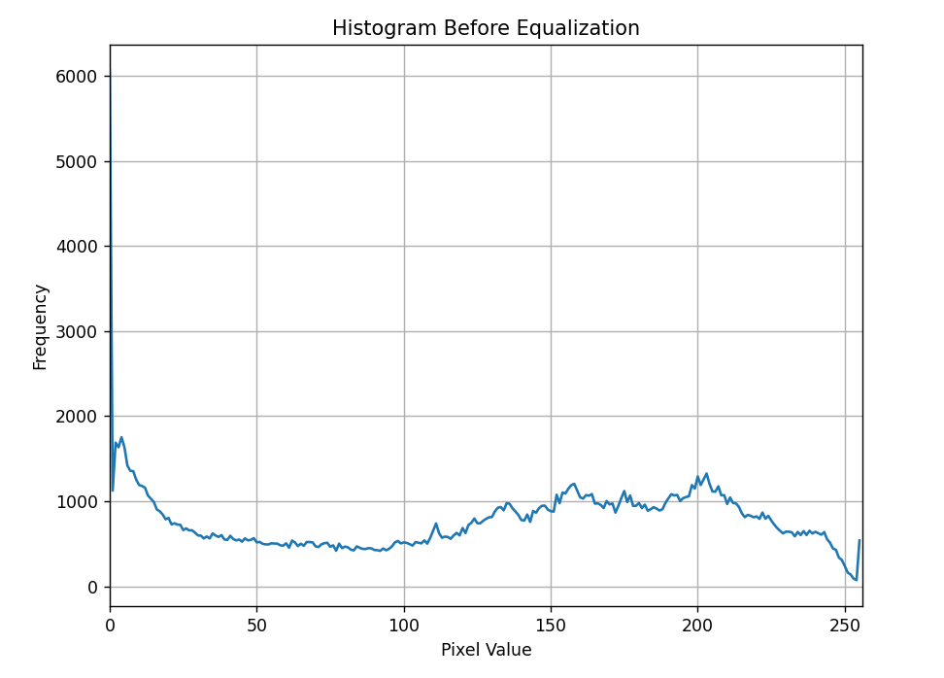
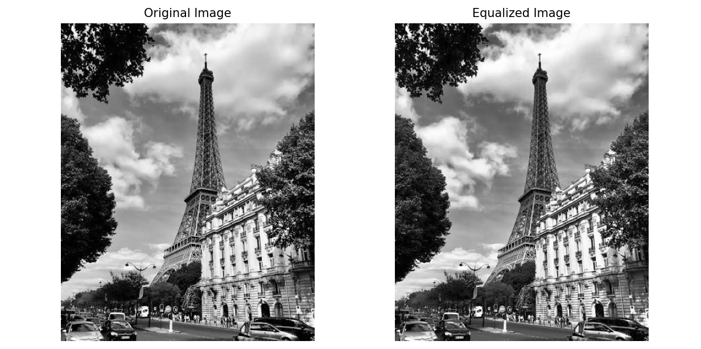
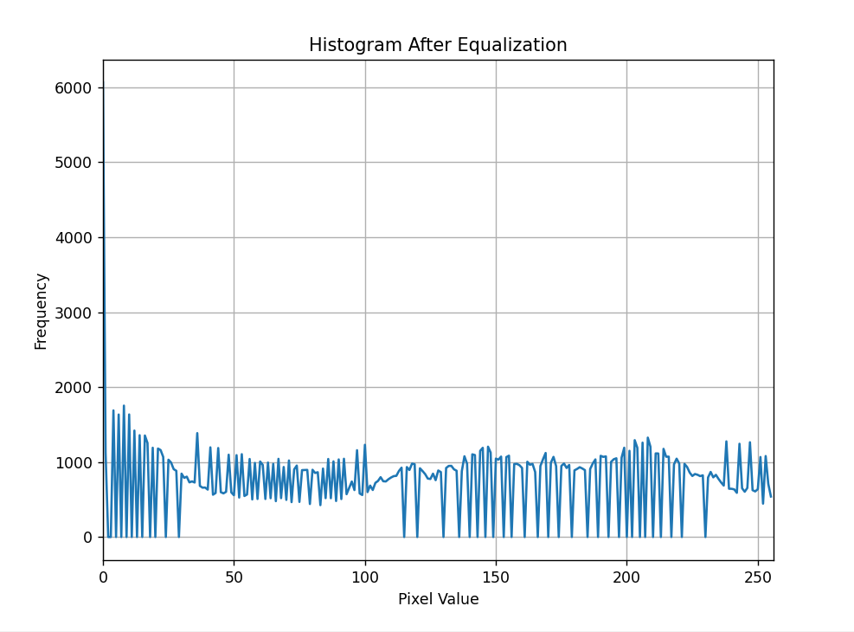

Expected Output
The program displays the original histogram, followed by the original and equalized images. It then displays the histogram of the equalized image. The equalized image is expected to have improved contrast compared with the original image.
Observation
The original histogram shows how the pixel intensities are distributed before enhancement. After histogram equalization, the intensity values are redistributed over a wider range. This generally improves the contrast and makes details more visible. The equalized histogram shows the change in intensity distribution compared with the original histogram.

2. Histogram Matching
Explanation
The second part of the program loads a source image and a reference image, both in grayscale. Histograms are calculated for both images using cv2.calcHist(). The histograms are normalized so that their total probability becomes 1. Next, the Cumulative Distribution Functions (CDFs) of both histograms are calculated using cumsum().
The program uses np.interp() to create a mapping between the source CDF and reference CDF. This mapping is then applied to every pixel of the source image to generate the matched image. Finally, the source, reference, and matched images are displayed side by side.
Code:-
import cv2
import numpy as np
import matplotlib.pyplot as plt

# -------------------------
# Load Source and Reference Images
# -------------------------
source_path = "D:\\ict\\sem5\\DSIP\\lab & theory session\\assignmentAndOEQ\\Experiment 8\\o.jpg" # Source image
reference_path = "D:\\ict\\sem5\\DSIP\\lab & theory session\\assignmentAndOEQ\\Experiment 8\\r.png" # Reference image

source_image = cv2.imread(source_path, cv2.IMREAD_GRAYSCALE)
reference_image = cv2.imread(reference_path, cv2.IMREAD_GRAYSCALE)

# Check if images are loaded
if source_image is None or reference_image is None:
print("Source or Reference image not found!")
exit()

# -------------------------
# Calculate Histograms
# -------------------------
source_hist = cv2.calcHist([source_image], [0], None, [256], [0, 256])
reference_hist = cv2.calcHist([reference_image], [0], None, [256], [0, 256])

# Normalize Histograms
source_hist /= source_hist.sum()
reference_hist /= reference_hist.sum()

# -------------------------
# Calculate Cumulative Distribution Functions (CDF)
# -------------------------
source_cdf = source_hist.cumsum()
reference_cdf = reference_hist.cumsum()

# -------------------------
# Perform Histogram Matching
# -------------------------
mapping = np.interp(source_cdf, reference_cdf, range(256))
matched_image = mapping[source_image].astype(np.uint8)

# -------------------------
# Display Images
# -------------------------
plt.figure(figsize=(12, 6))

plt.subplot(1, 3, 1)
plt.title("Source Image")
plt.imshow(source_image, cmap="gray")
plt.axis("off")

plt.subplot(1, 3, 2)
plt.title("Reference Image")
plt.imshow(reference_image, cmap="gray")
plt.axis("off")

plt.subplot(1, 3, 3)
plt.title("Matched Image")
plt.imshow(matched_image, cmap="gray")
plt.axis("off")

plt.tight_layout()
plt.show()

# -------------------------
# Display Histograms
# -------------------------
plt.figure(figsize=(12, 4))

plt.subplot(1, 3, 1)
plt.title("Source Histogram")
plt.plot(source_hist)

plt.subplot(1, 3, 2)
plt.title("Reference Histogram")
plt.plot(reference_hist)

plt.subplot(1, 3, 3)
plt.title("Matched Histogram")
matched_hist = cv2.calcHist([matched_image], [0], None, [256], [0, 256])
plt.plot(matched_hist)

plt.tight_layout()
plt.show()
Expected Output
The output displays three images:
- Source Image
- Reference Image
- Matched Image
The matched image should have an intensity distribution that is closer to the reference image.
Observation
The source image initially has its own intensity distribution, while the reference image has a different distribution. Histogram matching modifies the source image's pixel values according to the reference image. As a result, the matched image obtains a visual appearance closer to the reference image. The effectiveness of the technique depends strongly on the selected reference image.
Output :-
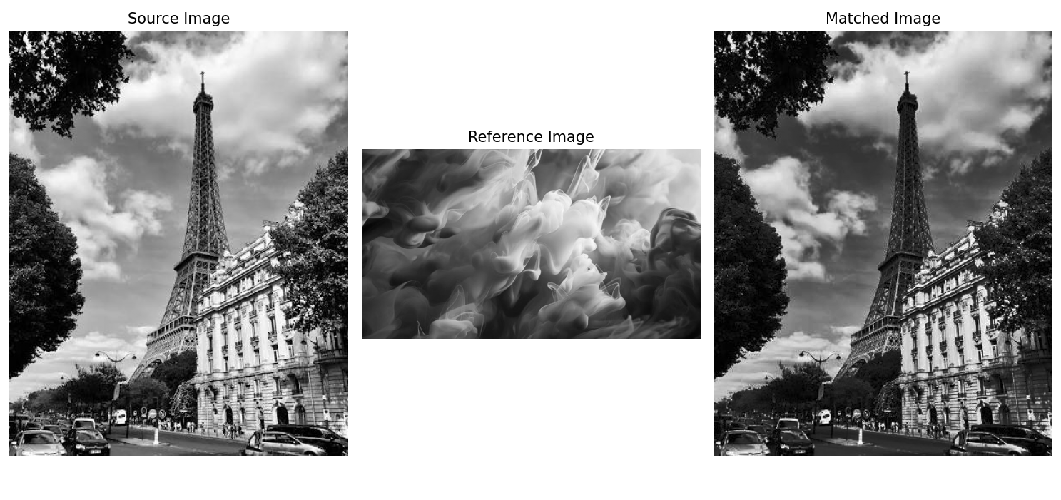
Conclusion
This experiment successfully demonstrated histogram equalization and histogram matching for image enhancement. Histogram equalization improved the contrast by redistributing pixel intensity values across the available range. Histogram matching changed the source image according to the intensity distribution of the reference image. The results showed that equalization is suitable for general contrast enhancement, while matching provides more control over the final appearance. Both techniques are useful methods in digital image processing, and the appropriate technique depends on the image condition and the desired enhancement result.

